**Lab W3D3**

**Qusetion 1.** Induced Graphs. Answer questions about the graph G = (V,E) displayed below

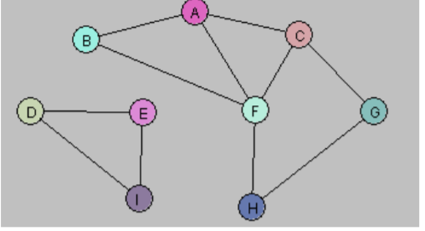

1. Let U = {A, B}. Draw G[U].

1. Let W = {A, C, G, F}. Draw G[W].

1. Let Y = {A, B, D, E}. Draw G[Y].

1. Consider the following subgraph H of G:

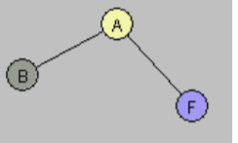

Is there a subset X of the vertex set V so that H = G[X]? Explain

🡪 No

E. Find a way to partition the vertex set V into two subsets V1, V2 so that each of the

induced graphs G[V1] and G[V2] is connected and G = G[V1] U G[V2].

**Qusetion 2**. The following graph has a Hamiltonian cycle. Find it. 